Alexis Ancrum
October 25, 2026

Project 3

Corner Grocer | Project Three
  - CS 210 • C++ Programming • Project Documentation
This project was about taking a simple list of grocery purchases and turning it into information the store could actually use. Instead of manually counting how many times each item appeared, I built a C++ program to do the counting and display the results in a way that is easy to read.

What my program does
The program reads the grocery input file, counts how often each item appears, and gives the user four menu options. Option 1 searches for a specific item. Option 2 shows the frequency for every item. Option 3 turns those numbers into a histogram using asterisks. Option 4 exits the program. It is also designed to create a backup of the item counts in a file named frequency.dat.

How I organized the code
I separated the work into three files so that everything would not be crowded into one place. GroceryTracker.h holds the class declaration. CornerGrocer.cpp handles the item counts and reporting functions. main.cpp controls the menu and responds to the choices entered by the user. Using a map for the item counts also keeps the results in alphabetical order.
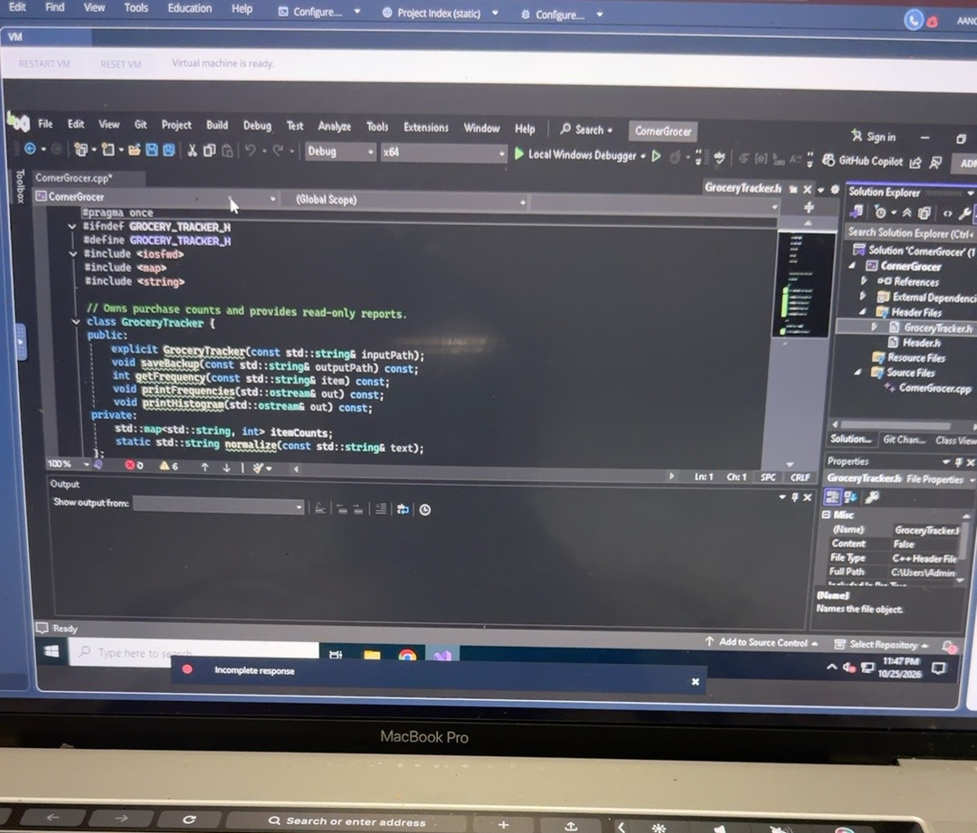
Figure 1. GroceryTracker.h and the project files in Visual Studio.

Building and troubleshooting
One of the biggest parts of this project was making sure the files were connected correctly. I worked through setting up the header and source files in the Visual Studio learning environment. Once the code was organized, the project built successfully. I also ran into an issue where the program could not locate the grocery input text file. I fixed that by saving the file in the project directory with the expected name.
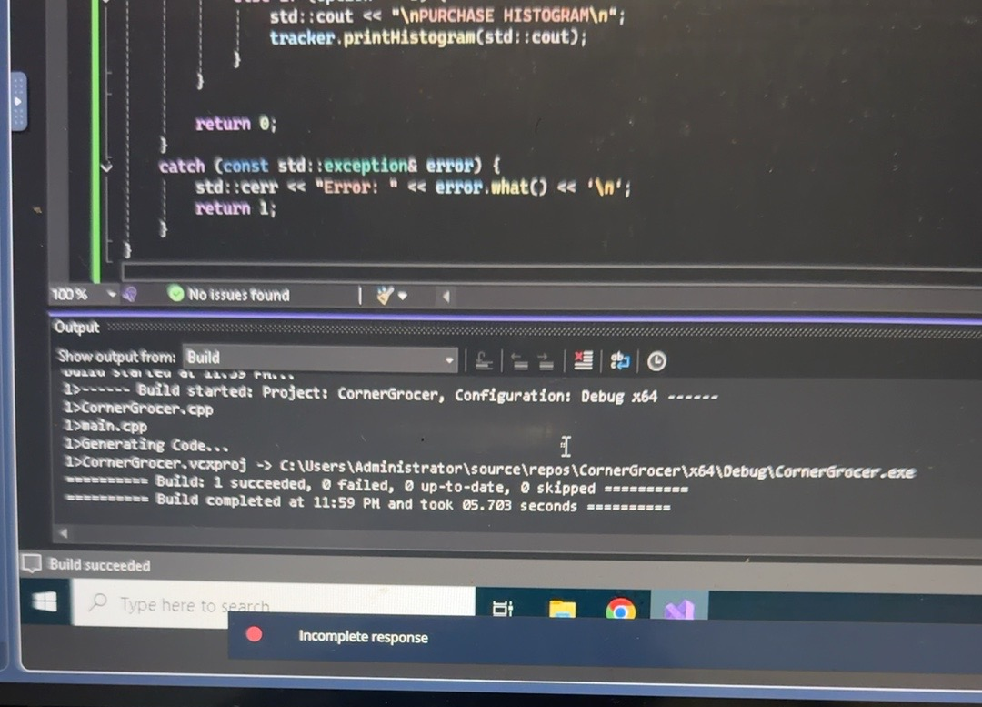
Figure 2. Visual Studio output showing a successful build.

What I tested
I confirmed that the project compiled with one successful build and zero failures. After fixing the input-file location, I ran the program and used the second menu option to display the item frequencies. The program read the data, listed the grocery items in alphabetical order, and returned to the main menu. In the output, Cranberries and Zucchini each appeared 10 times, Cucumbers appeared 9 times, and Broccoli appeared 7 times.
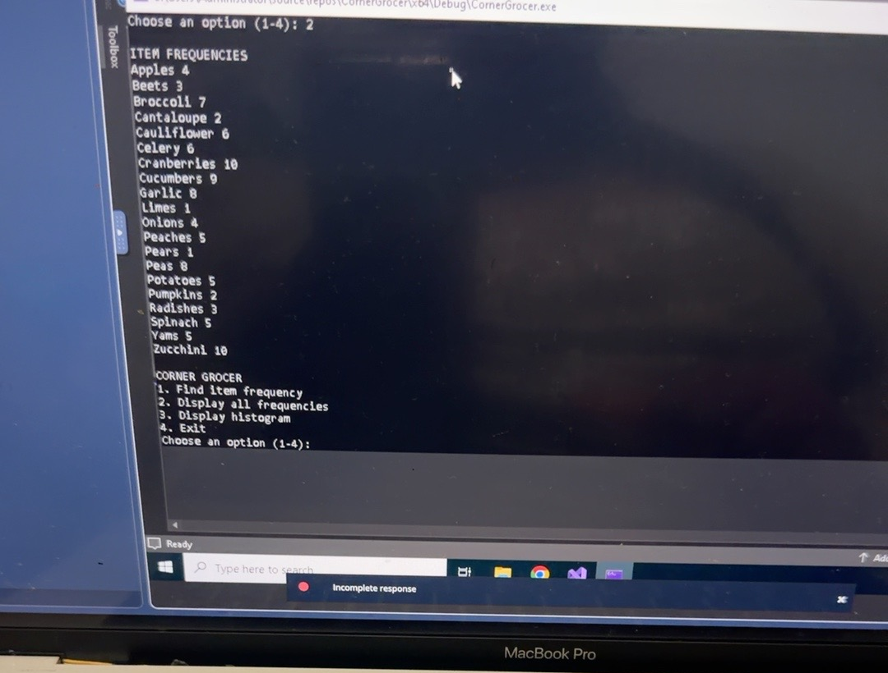
Figure 3. Program output showing the frequency report and menu.

What I would improve
If I continued working on this program, I would make it easier to choose a different input file instead of relying on one filename. I would also like to add a quick summary of the most and least purchased items. That would make it easier for the store to spot patterns without having to look through the entire list.

What I learned
This project gave me more practice working with classes, maps, text files, and menu-based programs in C++. It also showed me that getting code to compile is only part of the process. The program still has to find its files and produce the results it is supposed to. Working through those issues helped me understand how the different parts of a C++ project fit together.

Files included with the project
GroceryTracker.h • CornerGrocer.cpp • main.cpp • CS210_Project_Three_Input_File.txt • frequency.dat (generated when the program runs)
Testing note: The screenshots confirm the successful build and frequency report. The histogram, individual-item search, and backup-file contents should also be checked before final submission.

Pseudocode: How the program works
I wrote out the basic steps of the program below to show how the grocery data moves from the input file to the different menu options. This helped me keep the logic organized before putting everything together in C++.

Start and load purchases
START PROGRAM
CREATE GroceryTracker using CS210_Project_Three_Input_File.txt
OPEN input file
IF file cannot be opened, report an error and stop
FOR each grocery item in the file
STANDARDIZE the item name
INCREASE that item's count in the map by 1
END FOR
WRITE each item and its count to frequency.dat

Display the menu and process selections
REPEAT
DISPLAY Corner Grocer menu (choices 1 through 4)
READ the user's selection
IF selection is not a whole number from 1 to 4
DISPLAY an invalid selection message
CONTINUE to menu
END IF
IF choice = 1 THEN
ASK for one grocery item
FIND item in the frequency map
DISPLAY its purchase count (or 0 if not found)
ELSE IF choice = 2 THEN
FOR each item in the frequency map
DISPLAY item name and purchase count
END FOR
ELSE IF choice = 3 THEN
FOR each item in the frequency map
DISPLAY item name and one * per purchase
END FOR
ELSE IF choice = 4 THEN
DISPLAY goodbye message
EXIT loop
END IF
UNTIL user exits or input ends
END PROGRAM
This pseudocode is a simplified outline of the C++ program. The actual code separates the grocery tracking functions into the GroceryTracker class and handles menu input inside main.cpp.

